Q1.

Code:

package Q_01;  
import javax.swing.*;  
public class SampleWindow {  
 public static void main(String[] args) {  
 JFrame myWindow=new JFrame();  
 myWindow.setSize(800,600);  
 myWindow.setTitle("Welcome to Java");  
 myWindow.setVisible(true);  
  
 }  
}

Output:

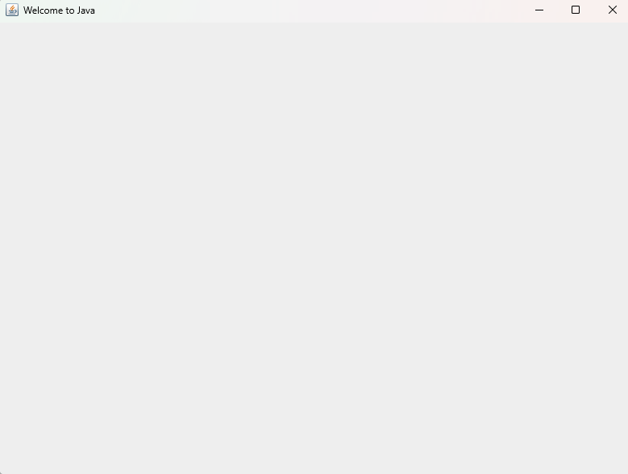

Q2.

Code:

package Q_02;  
import javax.swing.*;  
import java.util.Scanner;  
public class SampleWindow1 {  
 public static void main(String[] args) {  
 Scanner name=new Scanner(System.*in*);  
 String firstName,lastName;  
 System.*out*.println("Enter your FistName");  
 firstName=name.next();  
 System.*out*.println("Enter your LastName");  
 lastName=name.next();  
  
 JFrame myWindow=new JFrame();  
 myWindow.setSize(300,400);  
 myWindow.setTitle(firstName+" " + lastName);  
 myWindow.setVisible(true);

}

}

Output:

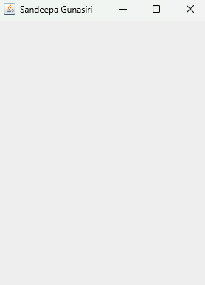

Q3.

Code:

package Q_03;  
import java.util.Scanner;  
public class Main {  
 public static void main(String[] args) {  
 Scanner name=new Scanner(System.*in*);  
 String firstName,lastName,middleName;  
 System.*out*.println("Enter your FistName");  
 firstName=name.next();  
 System.*out*.println("Enter your middleName");  
 middleName=name.next();  
 System.*out*.println("Enter your LastName");  
 lastName=name.next();  
 String middleInitial=middleName.substring(0,1);  
 System.*out*.println("Full name is:"+ firstName+" "+middleInitial+"."+" "+lastName);  
  
 }  
  
}

Output:

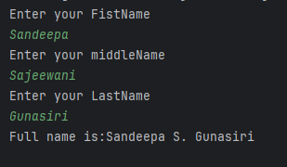

Q4.

Code:

package Q_04;  
  
import java.text.SimpleDateFormat;  
import java.util.Date;  
  
public class Main {  
 public static void main(String[] args) {  
 SimpleDateFormat sdf=new SimpleDateFormat("dd/MMMM/yyyy");  
 Date today=new Date();  
 System.*out*.println(sdf.format(today));  
 }  
  
}

Output:

Q5.

Code:

package Q_05;  
  
import java.text.SimpleDateFormat;  
import java.util.Date;  
  
public class Main {  
 public static void main(String[] args) {  
 SimpleDateFormat sdf=new SimpleDateFormat("EEEE,MMMM MM,yyyy");  
 Date today=new Date();  
 System.*out*.println(sdf.format(today));  
 }  
}

Output:

Q6.

Code:

package Q_06;  
  
import javax.swing.*;  
import java.util.Scanner;  
  
public class Main {  
 public static void main(String[] args) {  
 JFrame window=new JFrame();  
 Scanner scan=new Scanner(System.*in*);  
 int width,height;  
 String title;  
 System.*out*.println("Enter width and height:");  
 width=scan.nextInt();  
 height=scan.nextInt();  
 System.*out*.println("Enter Title:");  
 title=scan.next();  
 window.setSize(width,height);  
 window.setTitle(title);  
 window.setVisible(true);  
  
 }  
}

Output:

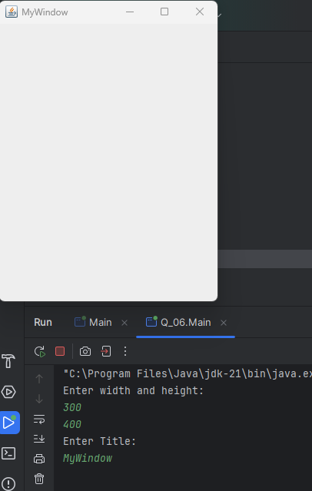

Q7.

Code:

package Q_07;  
import javax.swing.*;  
import java.text.SimpleDateFormat;  
import java.util.Date;  
public class Main {  
 public static void main(String[] args) {  
 Date today=new Date();  
 SimpleDateFormat sdf=new SimpleDateFormat("hh:mm:ss a");  
 JFrame window=new JFrame();  
 window.setSize(500,600);  
 window.setTitle(sdf.format(today));  
 window.setVisible(true);  
 }  
}

Output:

Q8.

Code:

package Q_08;  
import java.util.Scanner;  
public class Main {  
 public static void main(String[] args) {  
 String name;  
 Scanner scan=new Scanner(System.*in*);  
 name=scan.nextLine();  
 int length=name.length();  
 int index=name.indexOf('!');  
 System.*out*.println(name.substring(0,index));  
 System.*out*.println(name.substring(index+1,length));  
 }  
}

Output:

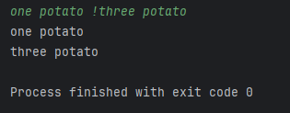

Q9.

Code:

package Q_09;  
  
import java.util.Scanner;  
public class Main {  
 public static void main(String[] args) {  
 Scanner scan=new Scanner(System.*in*);  
 String string;  
 string=scan.nextLine();  
 int length=string.length();  
 System.*out*.println(length);  
 System.*out*.println(string.substring(0,1));  
 System.*out*.println(string.substring(length-1,length));  
  
  
 }  
}

Output:

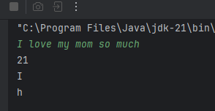

Q10.

Code:

package Q_10;  
import java.util.Scanner;  
public class Q10 {  
 public static void main(String[] args) {  
 Scanner scan = new Scanner(System.*in*);  
 System.*out*.println("Enter word");  
 String word = scan.next();  
 int length = word.length();  
 int middleIndex = 0;  
 if (length % 2 == 1) {  
 middleIndex = length / 2;  
 System.*out*.println("Middle character=" + word.substring(middleIndex, middleIndex + 1));}  
   
 else  
 {  
 System.*out*.println("Error");  
 }

}

}

Output:

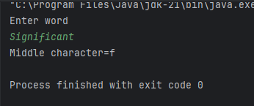

Q11.

Code:

package Q_11;

import java.util.Scanner;

public class Q11 {

public static void main(String[] args) {

Scanner name=new Scanner(System.in);

String firstName,lastName,middleName;

System.out.println("Enter your FistName");

firstName=name.next();

System.out.println("Enter your middleName");

middleName=name.next();

System.out.println("Enter your LastName");

lastName=name.next();

String middleInitial=middleName.substring(0,1);

System.out.println(lastName+","+firstName+" "+middleInitial+".");

}

}

Output:

Q12.

Code:

package Q_12;  
import javax.swing.*;  
public class Q12 {  
 public static void main(String[] args) {  
 JFrame frame=new JFrame();  
 frame.setSize(300,200);  
 frame.setTitle("My First Frame");  
 frame.setVisible(true);  
 frame.setLocation(100,50);  
 }  
}

Output:

